Mevada Zalak

Assignment :- 1

Module -1: Understanding of Hardware and Its Components

Section 1: Multiple Choice

1. Which of the following is NOT a component of the CPU?

Ans: RAM

1. What is the function of RAM in a computer?

Ans: RAM is the temporary, fast memory of a computer that stores data and instructions currently in use by the CPU.

1. Which of the following is a primary storage device?

Ans: RAM

1. What is the purpose of a GPU?

Ans: GPU’s purpose is to process graphics and heavy parallel calculations faster than a CPU.

Section 2: True or False

1. True or False: The motherboard is the main circuit board of a computer where other components are attached.

Ans: True

1. True or False: A UPS (Uninterruptible Power Supply) is a hardware device that provides emergency power to a load when the input power source fails.

Ans: True

1. True or False: An expansion card is a circuit board that enhances the functionality of a component.

Ans: True

Section 3: Short Answer

1. Explain the difference between HDD and SSD.

Ans:

|  |  |
| --- | --- |
| HDD | SDD |
| 1.HDD :- Hard disk drive | 1.SDD:- Solid state drive |
| 2. HDDs use spinning magnetic platters and a mechanical arm to read and write data, which involves moving parts. | 2.SSDs store data electronically in flash memory (integrated circuits) and have no moving parts |
| 3. read data time is very high | 3.Read data time is very slow |
| 4. Usually bigger and cheaper | 4. Smaller and more costly |
| 5. 6-12 walts | 5. 2 walts and save power |

1. Describe the function of BIOS in a computer system.

Ans:- BIOS starts the computer, checks hardware, and loads the operating system.

**Function of BIOS in a computer system:**

1. **Power-On Self Test (POST):** When the computer starts, BIOS checks hardware components to ensure they are working properly.
2. **Boot Loader:** BIOS finds and loads the operating system from storage
3. **Hardware Initialization:** It initializes and configures hardwarebefore handing control to the OS.
4. **Provides Firmware Interface:** It allows low-level communication between the operating system and hardware devices.
5. List and briefly explain three input devices commonly used with computers.

Ans:- 1.**Keyboard** – Used to enter text, numbers, and commands into the computer through keys.

2.**Mouse** – A pointing device that controls the movement of a cursor on the screen, allowing users to select and interact with items.

3.**Scanner** – Captures images, documents, or photos and converts them into a digital format for the computer.

Section 4: Practical Application

1. Identify and label the following components on a diagram of a motherboard:

● CPU ● RAM slots ● SATA connectors ● PCI-E slot

Ans:-

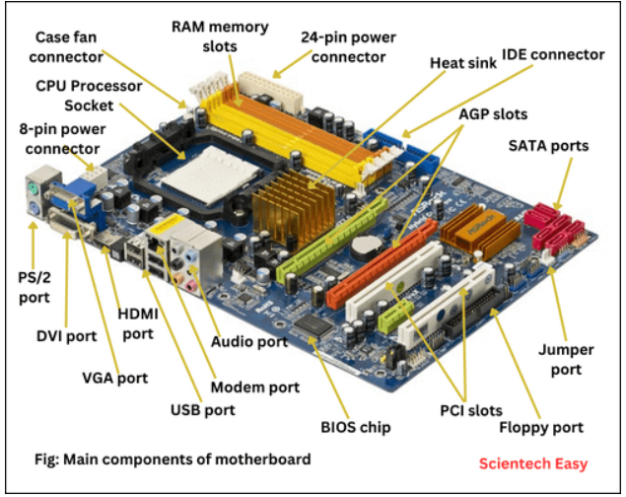

1. Demonstrate how to install a RAM module into a computer.

Ans:- **1. Power Down and Unplug**

* Shut down the computer completely.
* Remove the power cable and any connected peripherals.
* Press the power button once after unplugging to discharge leftover electricity.

**2. Open the Computer Case**

* Place the case on a flat surface.
* Remove the side panel using a screwdriver (if needed).

**3. Locate the RAM Slots (DIMM slots)**

* Find the **long slots** near the CPU (usually 2–4 slots).
* They may already have some RAM installed.

**4. Prepare the RAM Module**

* Hold the RAM by the **edges only** (avoid touching the gold contacts).
* Check the **notch** in the connector — it ensures correct alignment.

**5. Open the Slot Clips**

* Push down the **plastic retention clips** on both ends of the slot.
* They will click outward.

**6. Insert the RAM**

* Align the notch in the RAM with the slot’s ridge.
* Press down firmly with **even pressure** on both ends until you hear a **click**.
* The clips should snap back into place automatically.

**7. Close the Case and Reconnect**

* Reattach the side panel.
* Reconnect the power cable and peripherals.

**8. Test the Installation**

* Power on the computer.
* Enter the **BIOS/UEFI** (press *Del*, *F2*, or similar key at startup).
* Check if the new RAM is detected.
* Alternatively, in Windows → Right-click **This PC** → **Properties** to view installed RAM

**Section 5: Essay**

1. **Discuss the importance of proper cooling mechanisms in a computer system. Include examples of cooling methods and their effectiveness.**

Ans:- 1. Performance Issues

How it works: Metal heat sinks absorb heat from CPU/GPU.

If cooling is not enough, the system reduces speed automatically to avoid damage (thermal throttling).

2. Hardware Damage

Prolonged overheating may damage sensitive parts like the motherboard, RAM, or hard disk.

3.System Instability

Overheating can cause sudden crashes, freezing, or unexpected shutdowns.

4.Reduced Lifespan

Components wear out faster when running at high temperature for long periods.

1. **Explain the concept of bus width and its significance in computer architecture.**

**Ans:-** A bus in computer architecture is a communication pathway that transfers data, instructions, and control signals between different components of a computer.

1. Data Transfer Capacity

* Wider bus = more bits transferred at once.
* Example: A 32-bit bus can transfer 32 bits in one cycle, while a 64-bit bus can transfer double that amount.

2. System Performance

* Larger bus width improves overall speed and efficiency.
* Example: 64-bit processors handle larger amounts of data and memory more efficiently than 32-bit processors.

3. Memory Addressing

* Bus width also affects how much memory can be addressed by the system.

4. Compatibility

* Software and operating systems must match the bus width.
* Example: A 32-bit OS cannot fully utilize a 64-bit bus/processor.